**VISVESVARAYA TECHNOLOGICAL UNIVERSITY**

**“JnanaSangama”, Belgaum -590014, Karnataka.**



**LAB REPORT**

**on**

**Analysis and Design of Algorithms**

***Submitted by***

**Name:Vignesh V**

**USN:1BM20CS186**

***in partial fulfillment for the award of the degree of***

**BACHELOR OF ENGINEERING**

***in***

**COMPUTER SCIENCE AND ENGINEERING**



**B.M.S. COLLEGE OF ENGINEERING**

**(Autonomous Institution under VTU)**

**BENGALURU-560019**

**May-2022 to July-2022**

**B. M. S. College of Engineering,**

**Bull Temple Road, Bangalore 560019**

(Affiliated To Visvesvaraya Technological University, Belgaum)

**Department of Computer Science and Engineering**



**CERTIFICATE**

This is to certify that the Lab work entitled “**Analysis and Design of Algorithms**” carried out by  **VIGNESH V(1BM20CS186),** who is bonafide student of **B. M. S. College of Engineering.** It is in partial fulfillment for the award of **Bachelor of Engineering in Computer Science and Engineering** of the Visvesvaraya Technological University, Belgaum during the year 2022. The Lab report has been approved as it satisfies the academic requirements in respect of **Analysis and Design of Algorithms - (19CS4PCADA)** work prescribed for the said degree.

Name of the Lab-In charge: Vikranth B N       **Dr. Jyothi S Nayak** Associate Professor Professor and Head

Department of CSE Department of CSE

BMSCE, Bengaluru BMSCE, Bengaluru

**Index Sheet13,15,19,22,24,28,32,36,,39,44,46,49,52,57,59**

| **Sl. No.** | **Experiment Title** | **Page No.** |
| --- | --- | --- |
| **1** | Write a recursive program to Solve  **a)** Towers-of-Hanoi problem **b)** To find GCD | **7** |
| **2** | Implement Recursive Binary search and Linear search and determine the time required to search an element. Repeat the experiment for different values of N and plot a graph of the time taken versus N. | **13** |
| **3** | Sort a given set of N integer elements using Selection Sort technique and compute its time taken. Run the program for different values of N and record the time taken to sort. | **15** |
| **4** | Write program to do the following:  **a)** Print all the nodes reachable from a given starting node in a digraph using BFS method.  **b)** Check whether a given graph is connected or not using DFS method. | **19** |
| **5** | Sort a given set of N integer elements using Insertion Sort technique and compute its time taken. | **22** |
| **6** | Write program to obtain the Topological ordering of vertices in a given digraph. | **24** |
| **7** | Implement Johnson Trotter algorithm to generate permutations. | **28** |
| **8** | Sort a given set of N integer elements using Merge Sort technique and compute its time taken. Run the program for different values of N and record the time taken to sort. | **32** |
| **9** | Sort a given set of N integer elements using Quick Sort technique and compute its time taken. | **35** |
| **10** | Sort a given set of N integer elements using Heap Sort technique and compute its time taken. | **37** |
| **11** | Implement Warshall’s algorithm using dynamic programming | **39** |
| **12** | Implement 0/1 Knapsack problem using dynamic programming. | **42** |
| **13** | Implement All Pair Shortest paths problem using Floyd’s algorithm. | **44** |
| **14** | Find Minimum Cost Spanning Tree of a given undirected graph using Prim’s algorithm. | **47** |
| **15** | Find Minimum Cost Spanning Tree of a given undirected graph using Kruskals algorithm. | **50** |
| **16** | From a given vertex in a weighted connected graph, find shortest paths to other vertices using Dijkstra’s algorithm. | **53** |
| **17** | 1. Implement “Sum of Subsets” using Backtracking. “Sum of Subsets” problem: Find a subset of a given set S = {s1,s2,……,sn} of n positive integers whose sum is equal to a given positive integer d. For example, if S = {1,2,5,6,8} and d = 9 there are two solutions {1,2,6} and {1,8}. A suitable message is to be displayed if the given problem instance doesn’t have a solution. | **55** |
| **18** | Implement “N-Queens Problem” using Backtracking. | **57** |

**Course Outcome**

| **CO1** | Ability to **analyze** time complexity of Recursive and Non-Recursive algorithms using asymptotic notations. |
| --- | --- |
| **CO2** | Ability to **design** efficient algorithms using various design techniques. |
| **CO3** | Ability to **apply** the knowledge of complexity classes P, NP, and NP-Complete and prove certain problems are NP-Complete |
| **CO4** | Ability to **conduct** practical experiments to solve problems using an appropriate designing method and find time efficiency. |

**Write a recursive program to Solve**

1. **Towers-of-Hanoi problem b) To find GCD**
2. **TOWER OF HANOI**

#include <stdio.h>

void toh(int n,char a,char b,char c)

{

if(n>0)

{

toh(n-1,a,c,b);

printf("move the disk from %c to %c\n",a,c);

toh(n-1,b,a,c);

}

}

int main()

{

int n;

char a,b,c;

printf("Enter the number of disks: ");

scanf("%d",&n);

toh(n,'a','b','c');

return 0;

}

**OUTPUT:**

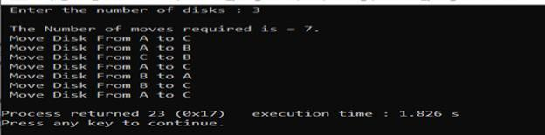

1. **GREATEST COMMON DIVISOR**

#include <stdio.h>

int gcd(int a,int b) {

if(b!=0)

return gcd(b,a%b);

else

return a;

}

void main()

{

int a,b,c;

printf("Enter two positive integers: ");

scanf("%d %d",&a,&b);

c=gcd(a,b);

printf("G.C.D of %d and %d is",a,b,c);

}

**OUTPUT:**

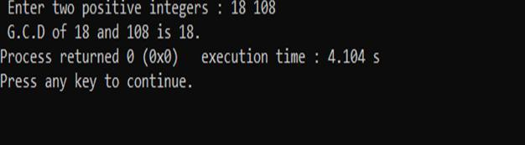

**2.Implement Recursive Binary search and Linear search and determine the time required to search an element. Repeat the experiment for different values of N and plot a graph of the time taken versus N.**

**CODE:**

#include<stdio.h>;

#include<time.h>;

#include<stdlib.h>;

int bin_srch(int [],int,int,int);

int lin_srch(int [],int,int,int);

int n,a[1000000];

int main() {

int ch,key,search_status,temp;

clock_t end,start;

unsigned long int i, j;

while(1) {

printf("\n1: Binary search\t 2: Linear search\t 3: Exit\n");

printf("\nEnter your choice:\t");

scanf("%d",&ch);

switch(ch) {

case 1:

n=1000;

while(n<=7000){

for(i=0;i<n;i++)

a[i]=i;

key=a[n-1];

start=clock();

search_status=bin_srch(a,0,n-1,key);

end=clock();

if(search_status==-1)

printf("\nKey Not Found");

else

printf("\n Key found at position %d",search_status);

printf("\nTime for n=%d is %f Secs",n,(double)(end-

start)/CLOCKS_PER_SEC);

n=n+1000;

}

break;

case 2:

n=1000;

while(n<=7000) {

for(i=0;i<n;i++)

a[i]=i;

key=a[n-1];

start=clock();

search_status=lin_srch(a,0,n-1,key);

end=clock();

if(search_status==-1)

printf("\nKey Not Found");

else

printf("\n Key found at position %d",search_status);

printf("\nTime for n=%d is %f Secs",n,(double)(end-

start)/CLOCKS_PER_SEC);

n=n+1000;

}

break;

default:

exit(0);

}

getchar();

}

}

int bin_srch(int a[],int low,int high,int key) {

for(int j=0;j<1000000;j++);

int mid;

if(low>high)

return -1;

mid=(low+high)/2;

if(key==a[mid])

return mid;

if(key<a[mid])

return bin_srch(a,low,mid-1,key);

else

return bin_srch(a,mid+1,high,key);

}

int lin_srch(int a[],int i,int high,int key) {

for(int j=0;j<10000;j++){ int temp=38/600;}

if(i>high)

return -1;

if(key==a[i])

return i;

else

return lin_srch(a,i+1,high,key);

}

**OUTPUT:**

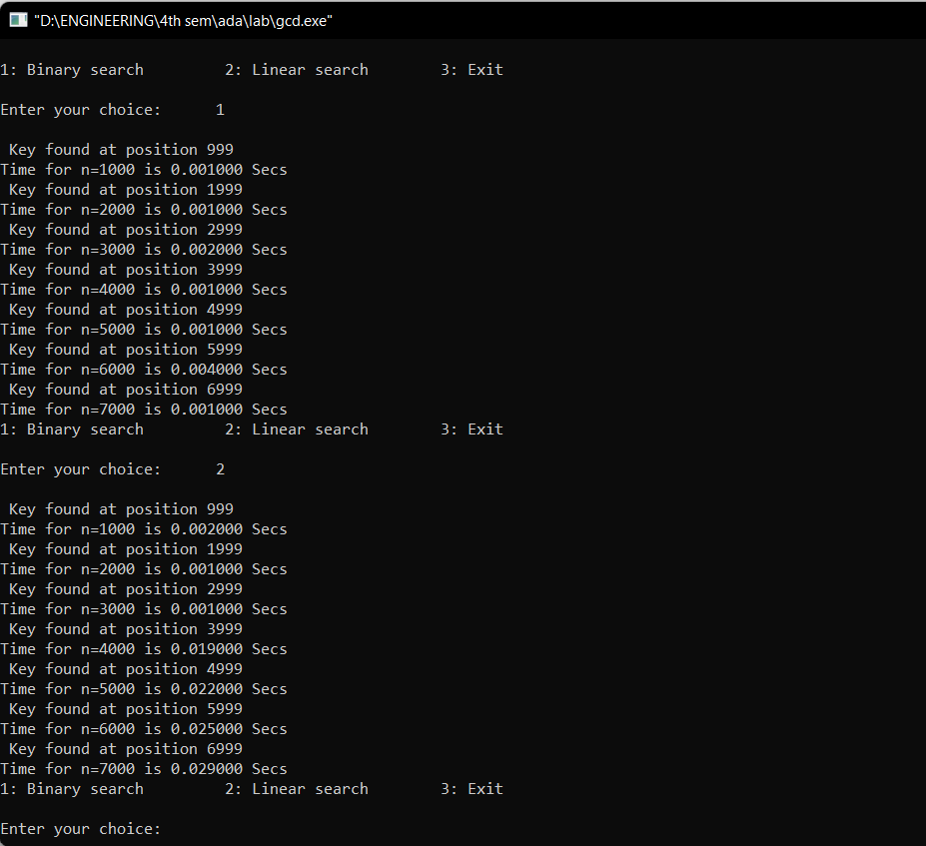

**GRAPH:**

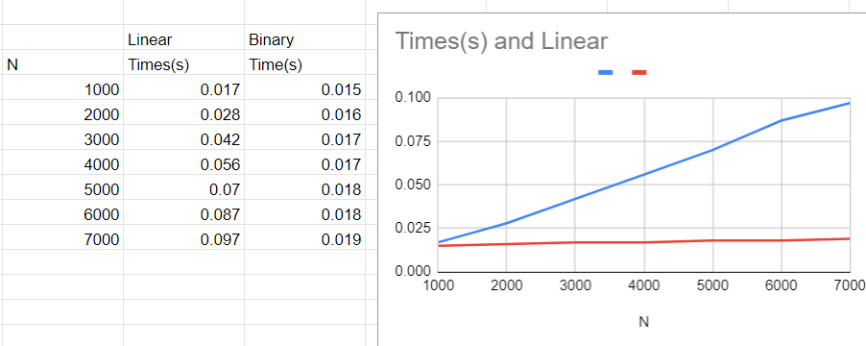

**3.Sort a given set of N integer elements using Selection Sort technique and compute its time taken. Run the program for different values of N and record the time taken to sort.**

**CODE:**

#include<stdio.h>

#include<time.h>

void sort(int x){

int n=x;

int a[n],max,i,j,k;

for(i=0;i<n;i++)

a[i]=i+1;

double start,end;

start = clock();

for(i=0;i<(n-1);i++){

max=a[i];

for(j=(i+1);j<n;j++){

if(max<a[j]){

max=a[j];

k=j;

}

}

if(a[i]!=max){

int temp=a[i];

a[i]=a[k];

a[k]=temp;

}

}

end = clock();

printf("Time taken to sort %d numbers is %f seconds \n",n,(end-start)/CLOCKS_PER_SEC);

n=n+1000;

}

void main(){

for(int x=1000;x<=10000;x+=1000){

sort(x);}

}

**OUTPUT:**

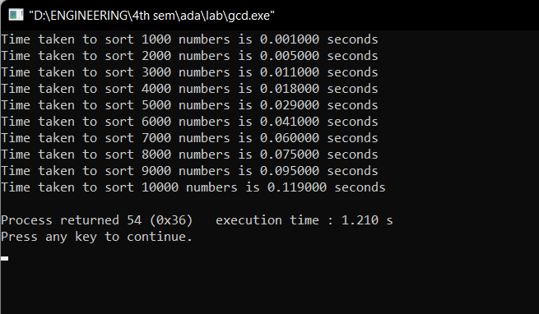

**GRAPH:**

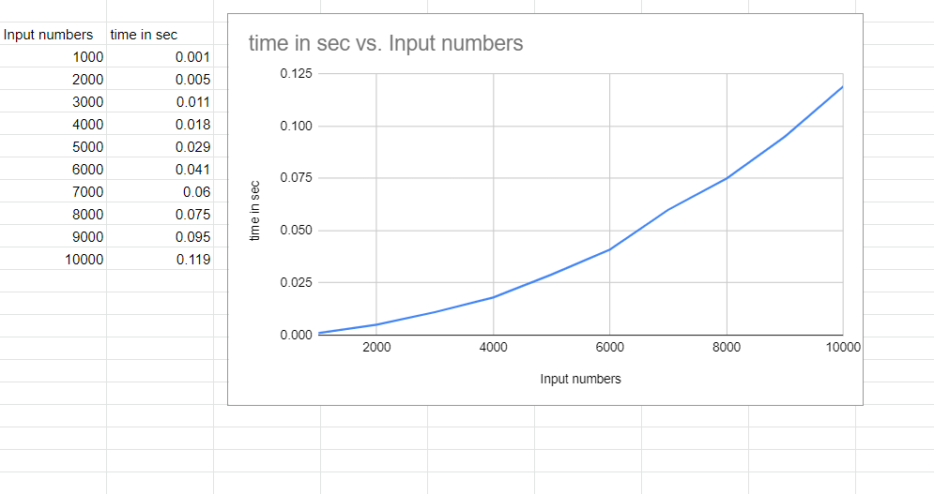

**4.Write program to do the following:**

**a) Print all the nodes reachable from a given starting node in a digraph using BFS method.**

**b) Check whether a given graph is connected or not using DFS method.**

1. **BREADTH FIRST SEARCH**

**CODE:**

#include<stdio.h>

#include<conio.h>

int a[15][15],n;

void bfs(int);

void main() {

int i,j,src;

printf("\nEnter the no of nodes:\t");

scanf("%d",&n);

printf("\nEnter the adjacency matrix:\n");

for(i=1;i<=n;i++)

for(j=1;j<=n;j++)

scanf("%d",&a[i][j]);

printf("\nEnter the source node:\t");

scanf("%d",&src);

bfs(src);

}

void bfs(int src) {

int q[15],f=0,r=-1,vis[15],i,j;

for(j=1;j<=n;j++)

vis[j]=0;

vis[src]=1;

r=r+1;

q[r]=src;

while(f<=r) {

i=q[f];

f=f+1;

for(j=1;j<=n;j++)

{

if(a[i][j]==1&&vis[j]!=1) {

vis[j]=1;

r=r+1;

q[r]=j;

}

}

}

for(j=1;j<=n;j++) {

if(vis[j]!=1)

printf("\nNode %d is not reachable",j);

else

printf("\nNode %d is reachable",j);

}

}

**OUTPUT**:

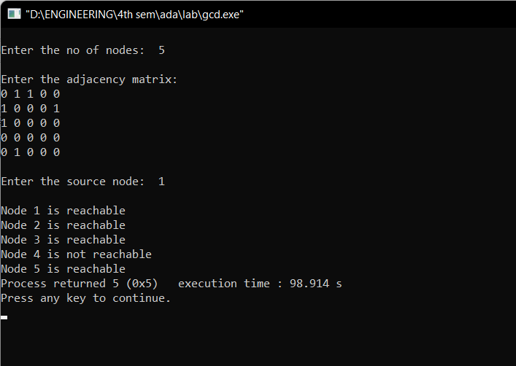

**b)DEPTH FIRST SEARCH**

**CODE:**

#include<stdio.h>

#include<conio.h>

int a[10][10],n,vis[10];

int dfs(int);

void main()

{

int i,j,src,ans;

for(j=1;j<=n;j++)

vis[j]=0;

printf("\nEnter the no of nodes:\t");

scanf("%d",&n);

printf("\nEnter the adjacency matrix:\n");

for(i=1;i<=n;i++)

for(j=1;j<=n;j++)

scanf("%d",&a[i][j]);

printf("\nEnter the source node:\t");

scanf("%d",&src);

ans=dfs(src);

if(ans==1)

printf("\nGraph is connected\n");

else

printf("\nGragh is not connected\n");

getch();

}

int dfs(int src)

{

int j;

vis[src]=1;

for(j=1;j<=n;j++)

if(a[src][j]==1&&vis[j]!=1)

dfs(j);

for(j=1;j<=n;j++) {

if(vis[j]!=1)

return 0;

}

return 1;

}

**OUTPUT**:

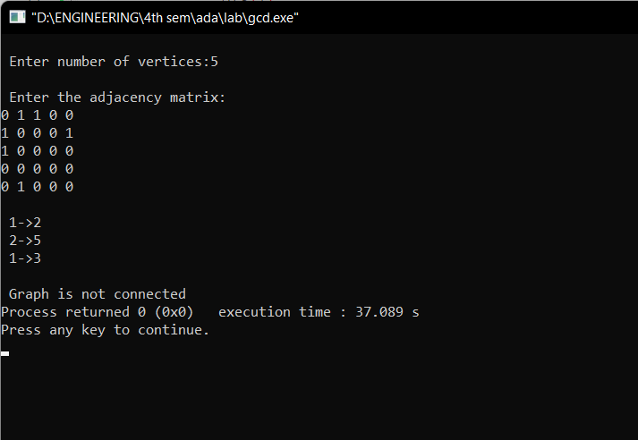

**5.Sort a given set of N integer elements using Insertion Sort technique and compute its time taken.**

**CODE:**

#include <math.h>

#include <stdio.h>

#include<stdlib.h>

#include<time.h>

void insertionSort(int arr[], int n)

{

int i, key, j;

for (i = 1; i < n; i++)

{

key = arr[i];

j = i - 1;

while (j >= 0 && arr[j] > key)

{

for(int k=0;k<100000;k++);

arr[j + 1] = arr[j];

j = j - -;

}

arr[j + 1] = key;

}

}

void main() {

int i, n;

clock_t start, end;

printf("ENTER ARRAY SIZE =");

scanf("%d", &n);

int arr[150000];

for (int j = 0; j < n; j++)

arr[j] = rand()%10000;

for (i = 0; i < n; i++)

printf(" %d", arr[i]);

printf("\n");

start = clock();

insertionSort(arr, n);

end = clock();

printf("\nSorted elements = ");

for (i = 0; i < n; i++)

printf(" %d", arr[i]);

printf("\n Time taken to sort %d Numbers is %f secs", n, (((double)(end - start)) / CLOCKS_PER_SEC));

}

**OUTPUT:**

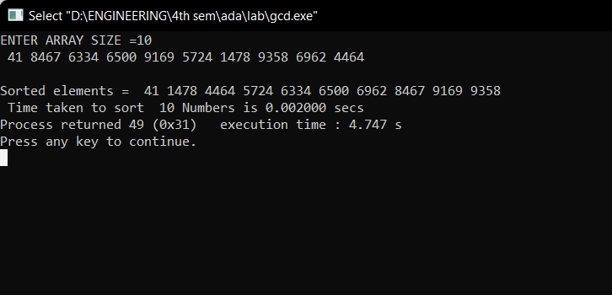

**GRAPH:**

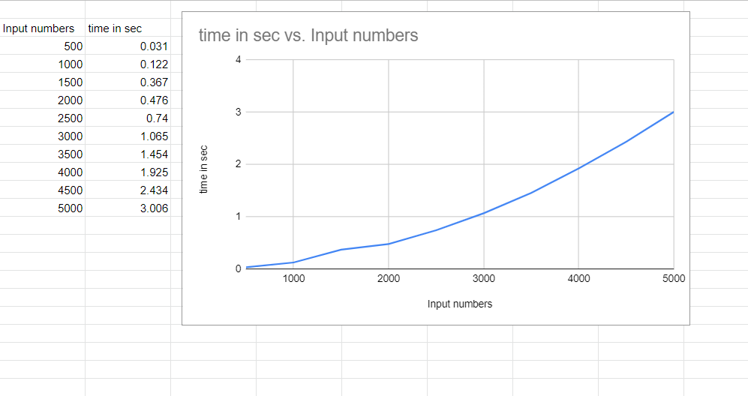

1. **Write program to obtain the Topological ordering of vertices in a given digraph.**

**CODE:**

#include<stdio.h>

#include<conio.h>

void source_removal(int n, int a[10][10]) {

int i,j,k,u,v,top,s[10],t[10],indeg[10],sum;

for(i=0;i<n;i++) {

sum=0;

for(j=0;j<n;j++)

sum+=a[j][i];

indeg[i]=sum;

}

top=-1;

for(i=0;i<n;i++) {

if(indeg[i]==0)

s[++top]=i;

}

k=0;

while(top!=-1) {

u=s[top--];

t[k++]=u;

for(v=0;v<n;v++) {

if(a[u][v]==1) {

indeg[v]=indeg[v]-1;

if(indeg[v]==0)

s[++top]=v;

}

}

}

printf("Topological order :");

for(i=0;i<n;i++)

printf(" %d", t[i]);

}

void main() {

int i,j,a[10][10],n;

printf("Enter number of nodes\n");

scanf("%d", &n);

printf("Enter the adjacency matrix\n");

for(i=0;i<n;i++)

for(j=0;j<n;j++)

scanf("%d", &a[i][j]);

source_removal(n,a);

getch();

}

**OUTPUT:**

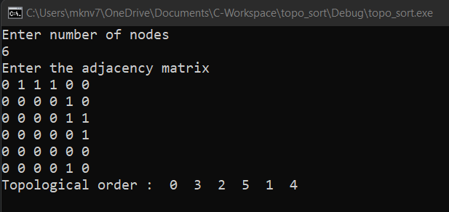

1. **Implement Johnson Trotter algorithm to generate permutations.**

**CODE:**

#include <stdio.h>

#include <stdlib.h>

int flag = 0;

int swap(int *a,int *b) {

int t = *a;

*a = *b;

*b = t;

}

int search(int arr[],int num,int mobile)

{

int g;

for(g=0;g<num;g++) {

if(arr[g] == mobile)

return g+1;

else

flag++;

}

return -1;

}

int find_Moblie(int arr[],int d[],int num)

{

int mobile = 0;

int mobile_p = 0;

int i;

for(i=0;i<num;i++)

{

if((d[arr[i]-1] == 0) && i != 0)

{

if(arr[i]>arr[i-1] && arr[i]>mobile_p)

{

mobile = arr[i];

mobile_p = mobile;

}

else

flag++;

}

else if((d[arr[i]-1] == 1) & i != num-1)

{

if(arr[i]>arr[i+1] && arr[i]>mobile_p)

{

mobile = arr[i];

mobile_p = mobile;

}

else

flag++;

}

else

flag++;

}

if((mobile_p == 0) && (mobile == 0))

return 0;

else

return mobile;

}

void permutations(int arr[],int d[],int num)

{

int i;

int mobile = find_Moblie(arr,d,num);

int pos = search(arr,num,mobile);

if(d[arr[pos-1]-1]==0)

swap(&arr[pos-1],&arr[pos-2]);

else

swap(&arr[pos-1],&arr[pos]);

for(int i=0;i<num;i++)

{

if(arr[i] > mobile)

{

if(d[arr[i]-1]==0)

d[arr[i]-1] = 1;

else

d[arr[i]-1] = 0;

}

}

for(i=0;i<num;i++)

{

printf(" %d ",arr[i]);

} }

int factorial(int k)

{

int f = 1;

int i = 0;

for(i=1;i<k+1;i++)

f = f*i;

return f;

}

int main()

{

int num = 0;

int i;

int j;

int z = 0;

printf("Johnson trotter algorithm to find all permutations of given numbers \n");

printf("Enter the number\n");

scanf("%d",&num);

int arr[num],d[num];

z = factorial(num);

printf("total permutations = %d",z);

printf("\nAll possible permutations are: \n");

for(i=0;i<num;i++)

{

d[i] = 0;

arr[i] = i+1;

printf(" %d ",arr[i]);

}

printf("\n");

for(j=1;j<z;j++) {

permutations(arr,d,num);

printf("\n");

}

return 0;

}

**OUTPUT**:

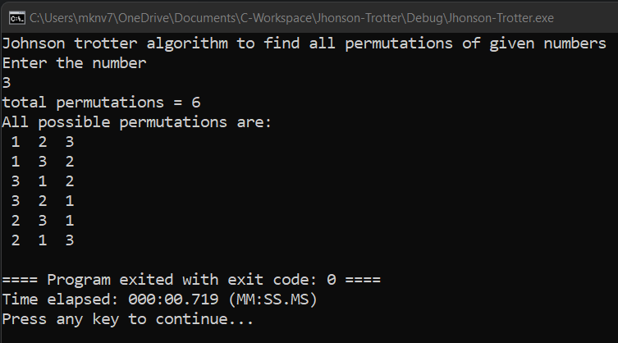

1. **Sort a given set of N integer elements using Merge Sort technique and compute its time taken. Run the program for different values of N and record the time taken to sort.**

**CODE:**

#include<stdio.h>

#include<stdlib.h>

#include<time.h>

void mergesort(int a[],int i,int j);

void merge(int a[],int i1,int j1,int i2,int j2);

int main()

{

clock_t start,end;

int a[30000],n=500,i;

while(n<=5000){

for(i=0;i<n;i++)

{

a[i] = rand()%1000;

}

start = clock();

mergesort(a,0,n-1);

end = clock();

printf("\n To Sort array of %d numbers ",n);

printf("required time is %lf secs",(double)(end-start)/CLOCKS_PER_SEC);

printf(“\n”);

n+=500;

}

}

void mergesort(int a[],int i,int j)

{

int mid;

if(i<j)

{

mid=(i+j)/2;

mergesort(a,i,mid);

mergesort(a,mid+1,j);

merge(a,i,mid,mid+1,j);

}

}

void merge(int a[],int i1,int j1,int i2,int j2)

{

int temp[30000];

int i,j,k;

i=i1;

j=i2;

k=0;

while(i<=j1 && j<=j2)

{

for(int j=0;j<100000;j++);

if(a[i]<a[j])

temp[k++]=a[i++];

else

temp[k++]=a[j++];

}

while(i<=j1)

temp[k++]=a[i++];

while(j<=j2)

temp[k++]=a[j++];

for(i=i1,j=0;i<=j2;i++,j++){

a[i]=temp[j];

}

}

OUTPUT:

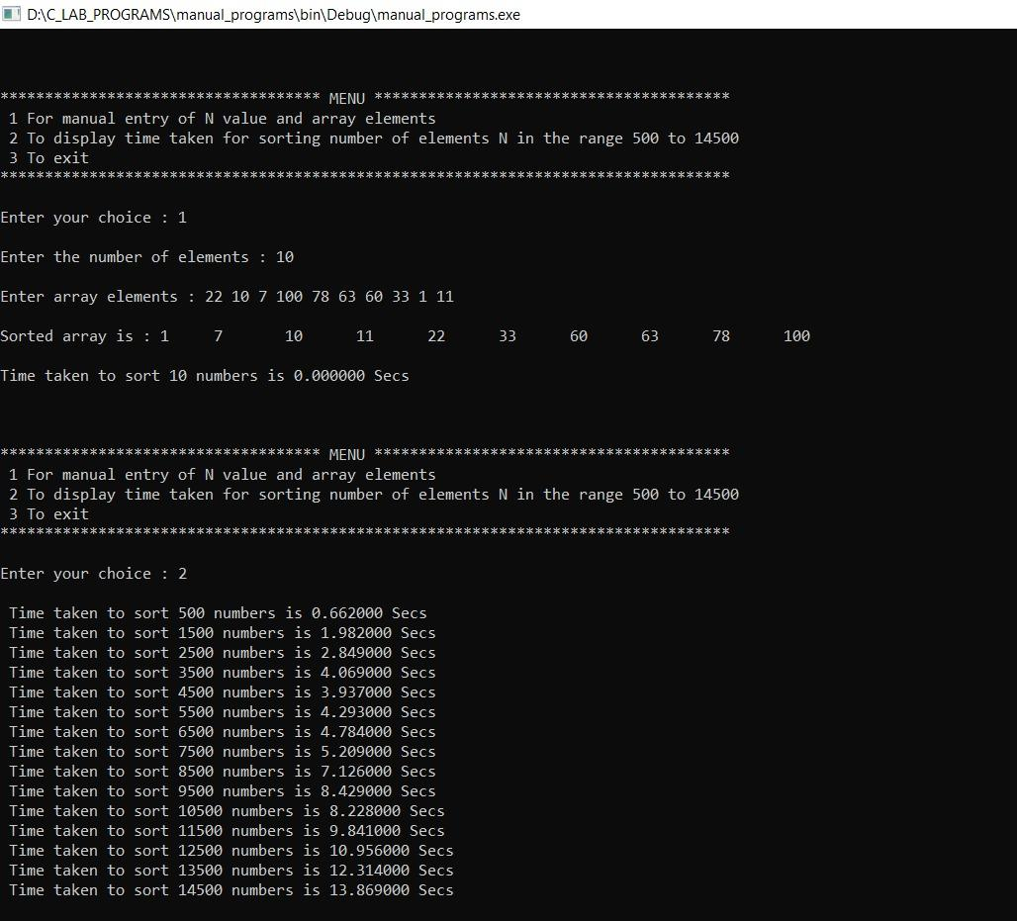

**GRAPH**:

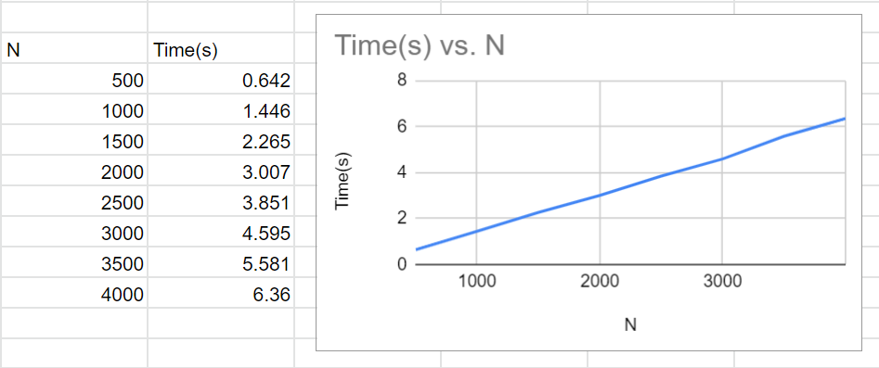

1. **Sort a given set of N integer elements using Quick Sort technique and compute its time taken.**

**CODE:**

#include<stdio.h>

#include<time.h>

#include<math.h>

#include<stdlib.h>

void quicksort(int number[5000],int first,int last)

{

int i, j, pivot, temp;

if(first<last)

{

pivot=first;

i=first;

j=last;

while(i<j)

{

for(int x=0;x<10000000;x++);

while(number[i]<=number[pivot]&&i<last)

i++;

while(number[j]>number[pivot])

j--;

if(i<j)

{

temp=number[i];

number[i]=number[j];

number[j]=temp;

}

}

temp=number[pivot];

number[pivot]=number[j];

number[j]=temp;

quicksort(number,first,j-1);

quicksort(number,j+1,last);

}

}

int main()

{

clock_t start,end;

int i, count, number[5000];

printf("No. of elements: ");

scanf("%d",&count);

printf("Enter %d elements: ", count);

for(i=0;i<count;i++)

{

number[i]=rand()%5000;

}

start = clock();

quicksort(number,0,count-1);

end = clock();

printf("Order of Sorted elements: ");

for(i=0;i<count;i++)

{

printf(" %d",number[i]);

}

printf("\nSeconds taken %lf",(double)(end-start)/CLOCKS_PER_SEC);

return 0;

}

**OUTPUT:**

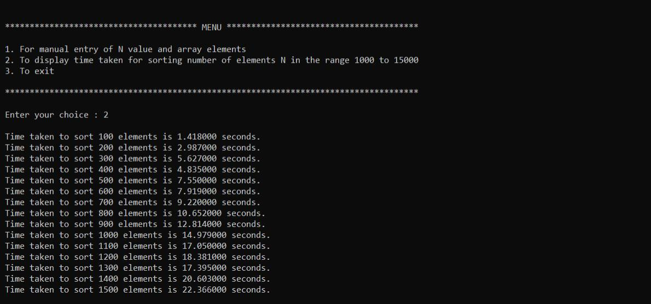

**GRAPH:**

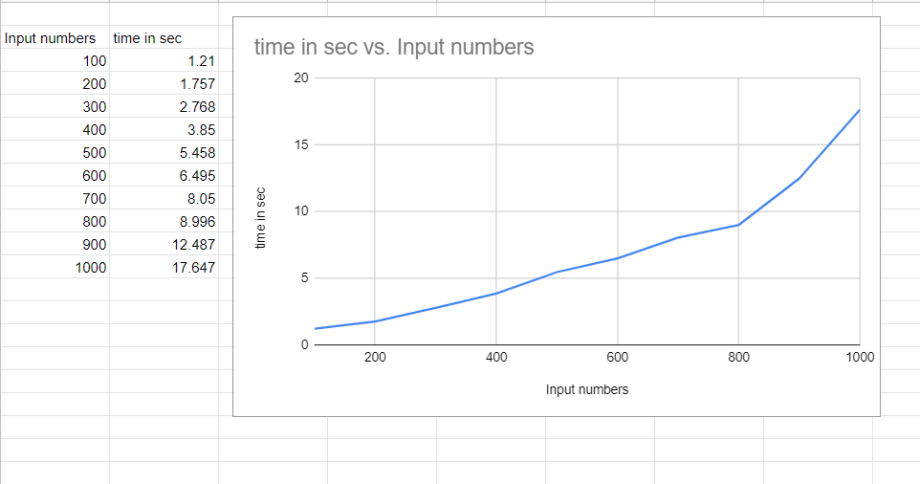

**10.Sort a given set of N integer elements using Heap Sort technique and compute its time taken.**

**CODE:**

#include <stdio.h>

#include<conio.h>

void heapify(int a[], int n, int i)

{

int largest = i;

int left = 2 * i + 1;

int right = 2 * i + 2;

if (left < n && a[left] > a[largest])

largest = left;

if (right < n && a[right] > a[largest])

largest = right;

if (largest != i) {

int temp = a[i];

a[i] = a[largest];

a[largest] = temp;

heapify(a, n, largest);

}

}

void heapSort(int a[], int n)

{ int i, temp;

for ( i = n / 2 - 1; i >= 0; i--)

heapify(a, n, i);

for ( i = n - 1; i >= 0; i--) {

temp = a[0];

a[0] = a[i];

a[i] = temp;

heapify(a, i, 0);

}

}

void printArr(int arr[], int n)

{ int i;

for ( i = 0; i < n; ++i)

{

printf("%d", arr[i]);

printf(" ");

}

}

int main()

{

int i,n;

int a[100];

clrscr();

printf("enter the no.of elements");

scanf("%d",&n);

for(i=0;i<n;i++)

{

a[i]=rand()%10;

}

printf("Before sorting array elements are - \n");

printArr(a, n);

heapSort(a, n);

printf("\nAfter sorting array elements are - \n");

printArr(a, n);

getch();

return 0;

}

**OUTPUT:**

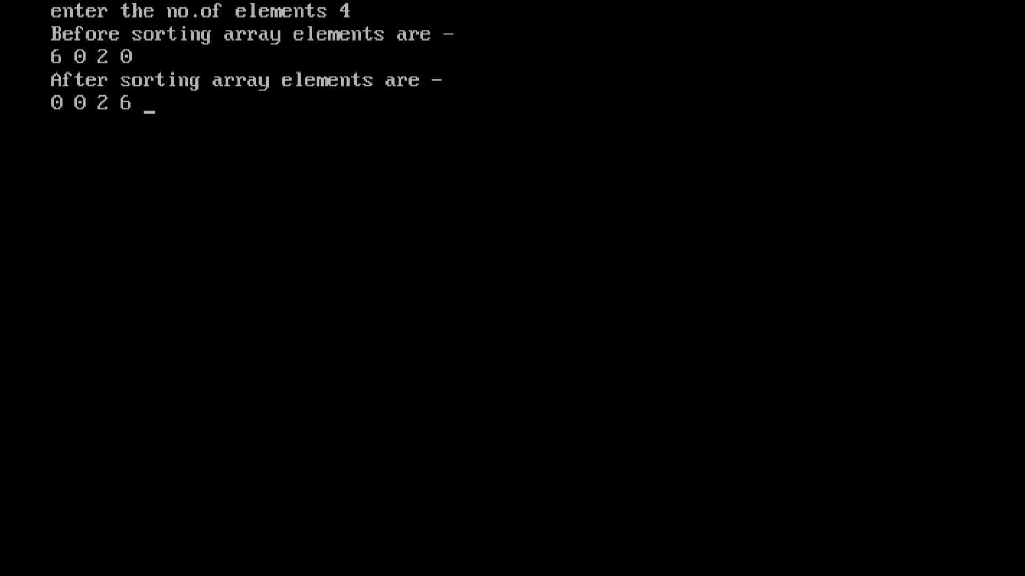

**11.Implement Warshall’s algorithm using dynamic programming**

**CODE:**

#include<stdio.h>

#include<math.h>

int max(int,int);

void warshall(int A[10][10],int n) {

int i,j,k;

for ( k=0;k<n;k++)

for ( i=0;i<n;i++)

for ( j=0;j<n;j++)

A[i][j]=max(A[i][j],A[i][k]&&A[k][j]);

}

int max(int a,int b) {

return a>b?a:b;

}

void main() {

int p[10][10];

int n;

int i,j;

printf("\n Enter the Number of Vertices : ");

scanf("%d",&n);

printf("\n Enter the adjacency matrix:\n");

for( i=0;i<n;i++)

{

for( j=0;j<n;j++)

scanf("%d",&p[i][j]);

}

printf("\n Matrix of input data: \n");

for ( i=0;i<n;i++) {

for ( j=0;j<n;j++)

printf(" %d\t",p[i][j]);

printf("\n");

}

warshall(p,n);

printf("\n Transitive closure: \n");

for ( i=0;i<n;i++) {

for ( j=0;j<n;j++)

printf(" %d\t",p[i][j]);

printf("\n");

}

}

**OUTPUT:**

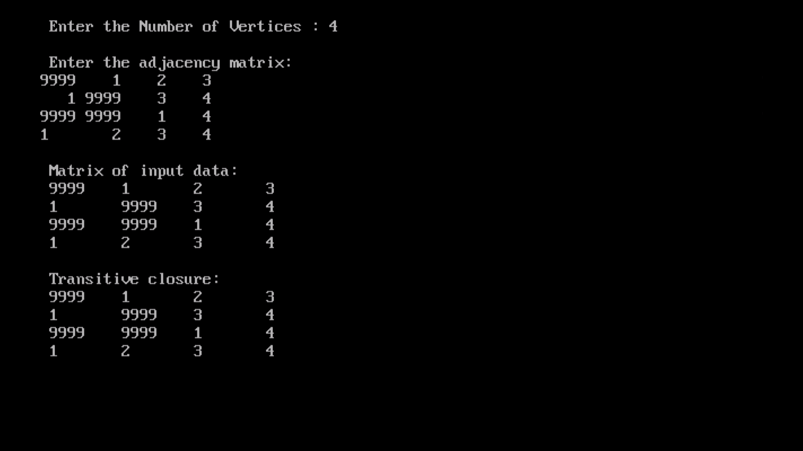

**12.Implement 0/1 Knapsack problem using dynamic programming.**

**CODE:**

#include<stdio.h>

#include<conio.h>

void knapsack();

int max(int,int);

int i,j,n,m,p[10],w[10],v[10][10];

void main()

{

printf("\nenter the no. of items:\t");

scanf("%d",&n);

printf("\nenter the weight of the each item:\n");

for(i=1;i<=n;i++)

{

scanf("%d",&w[i]);

}

printf("\nenter the profit of each item:\n");

for(i=1;i<=n;i++)

{

scanf("%d",&p[i]);

}

printf("\nenter the knapsack's capacity:\t");

scanf("%d",&m);

knapsack();

getch();

}

void knapsack()

{

int x[10];

for(i=0;i<=n;i++)

{

for(j=0;j<=m;j++)

{

if(i==0||j==0)

{

v[i][j]=0;

}

else if(j-w[i]<0)

{

v[i][j]=v[i-1][j];

}

else

{

v[i][j]=max(v[i-1][j],v[i-1][j-w[i]]+p[i]);

}

}

}

printf("\nthe output is:\n");

for(i=0;i<=n;i++)

{

for(j=0;j<=m;j++)

{

printf("%d\t",v[i][j]);

}

printf("\n\n");

}

printf("\nthe optimal solution is %d",v[n][m]);

printf("\nthe solution vector is:\n");

for(i=n;i>=1;i--)

{

if(v[i][m]!=v[i-1][m])

{

x[i]=1;

m=m-w[i];

}

else

{

x[i]=0;

}

}

for(i=1;i<=n;i++)

{

printf("%d\t",x[i]);

}

}

int max(int x,int y)

{

if(x>y)

{

return x;

}

else

{

return y;

}

}

**OUTPUT:**

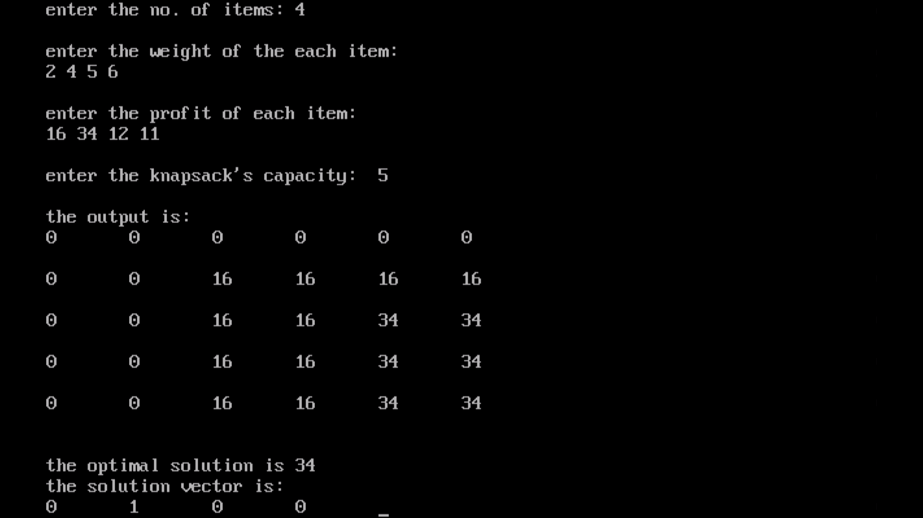

**13.Implement All Pair Shortest paths problem using Floyd’s algorithm**.

**CODE:**

#include<stdio.h>

#include<conio.h>

int a[10][10],n;

void floyds();

int min(int,int);

void main()

{

int i,j;

printf("\nenter the no. of vertices:\t");

scanf("%d",&n);

printf("\nenter the cost matrix:\n");

for(i=1;i<=n;i++)

{

for(j=1;j<=n;j++)

{

scanf("%d",&a[i][j]);

}

}

floyds();

getch();

}

void floyds()

{

int i,j,k;

for(k=1;k<=n;k++)

{

for(i=1;i<=n;i++)

{

for(j=1;j<=n;j++)

{

a[i][j]=min(a[i][j],a[i][k]+a[k][j]);

}

}

}

printf("\nall pair shortest path matrix is:\n");

for(i=1;i<=n;i++)

{

for(j=1;j<=n;j++)

{

printf("%d\t",a[i][j]);

}

printf("\n\n");

}

}

int min(int x,int y)

{

if(x<y)

{

return x;

}

else

{

return y;

}

}

**OUTPUT:**

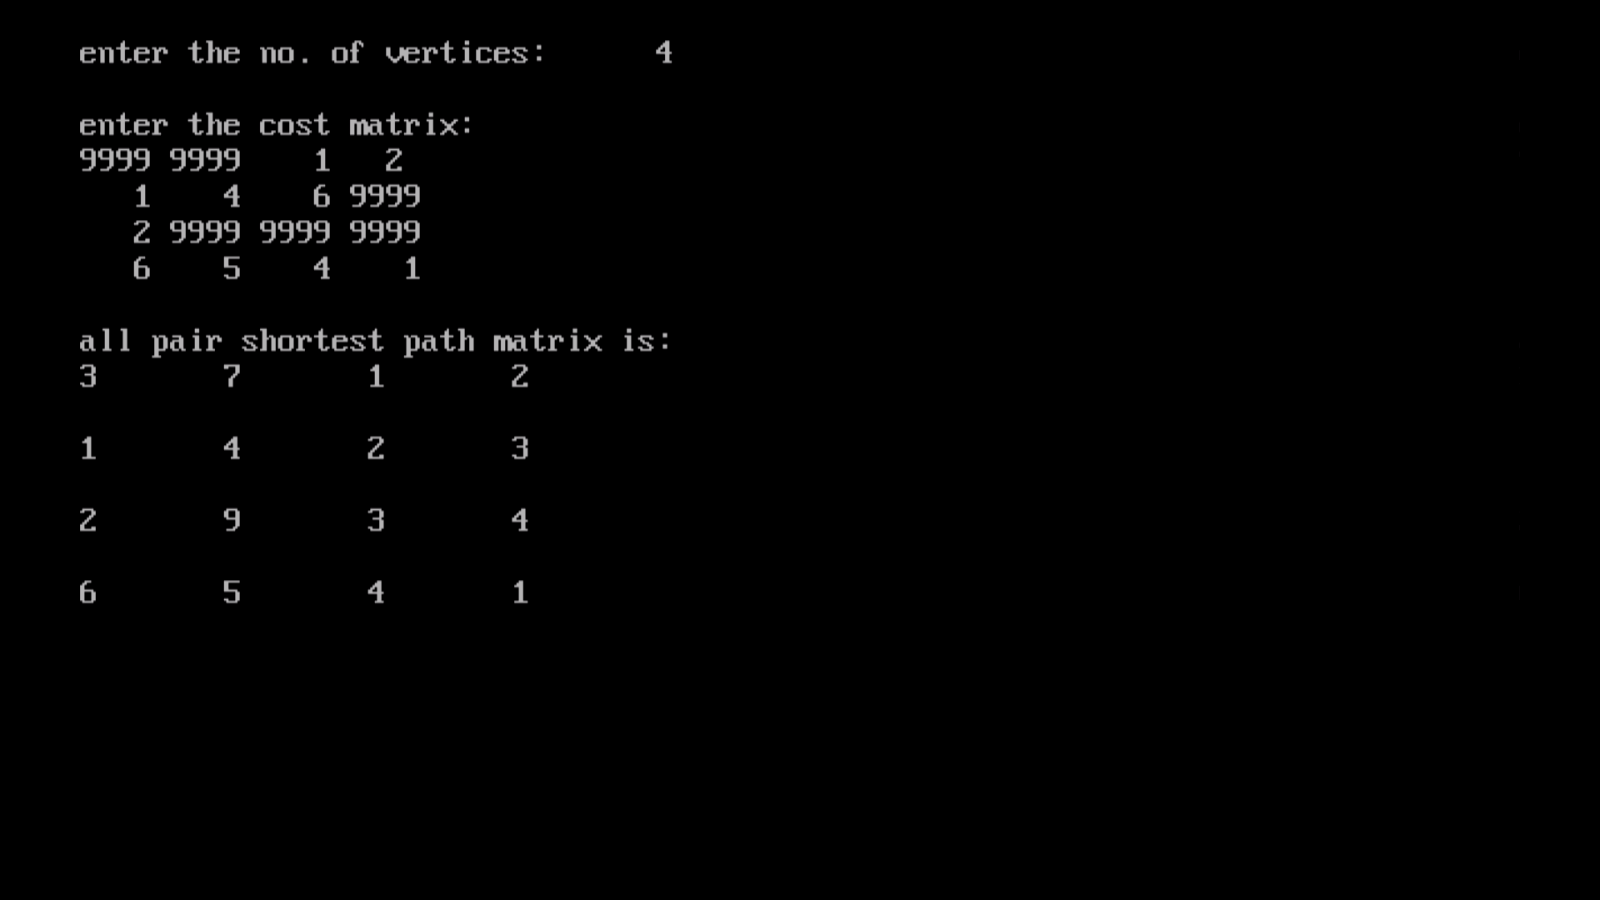

**14.Find Minimum Cost Spanning Tree of a given undirected graph using Prim’s algorithm.**

**CODE:**

#include<stdio.h>

#include<conio.h>

#include<process.h>

void prims();

int c[10][10],n;

void main()

{

int i,j;

clrscr();

printf("\nenter the no. of vertices:\t");

scanf("%d",&n);

printf("\nenter the cost matrix:\n");

for(i=1;i<=n;i++)

{

for(j=1;j<=n;j++)

{

scanf("%d",&c[i][j]);

}

}

prims();

getch();

}

void prims()

{

int i,j,u,v,min;

int ne=0,mincost=0;

int elec[10];

for(i=1;i<=n;i++)

{

elec[i]=0;

}

elec[1]=1;

while(ne!=n-1)

{

min=9999;

for(i=1;i<=n;i++)

{

for(j=1;j<=n;j++)

{

if(elec[i]==1)

{

if(c[i][j]<min)

{

min=c[i][j];

u=i;

v=j;

}

}

}

}

if(elec[v]!=1)

{

printf("\n%d----->%d=%d\n",u,v,min);

elec[v]=1;

ne=ne+1;

mincost=mincost+min;

}

c[u][v]=c[v][u]=9999;

}

printf("\nmincost=%d",mincost);

}

**OUTPUT:**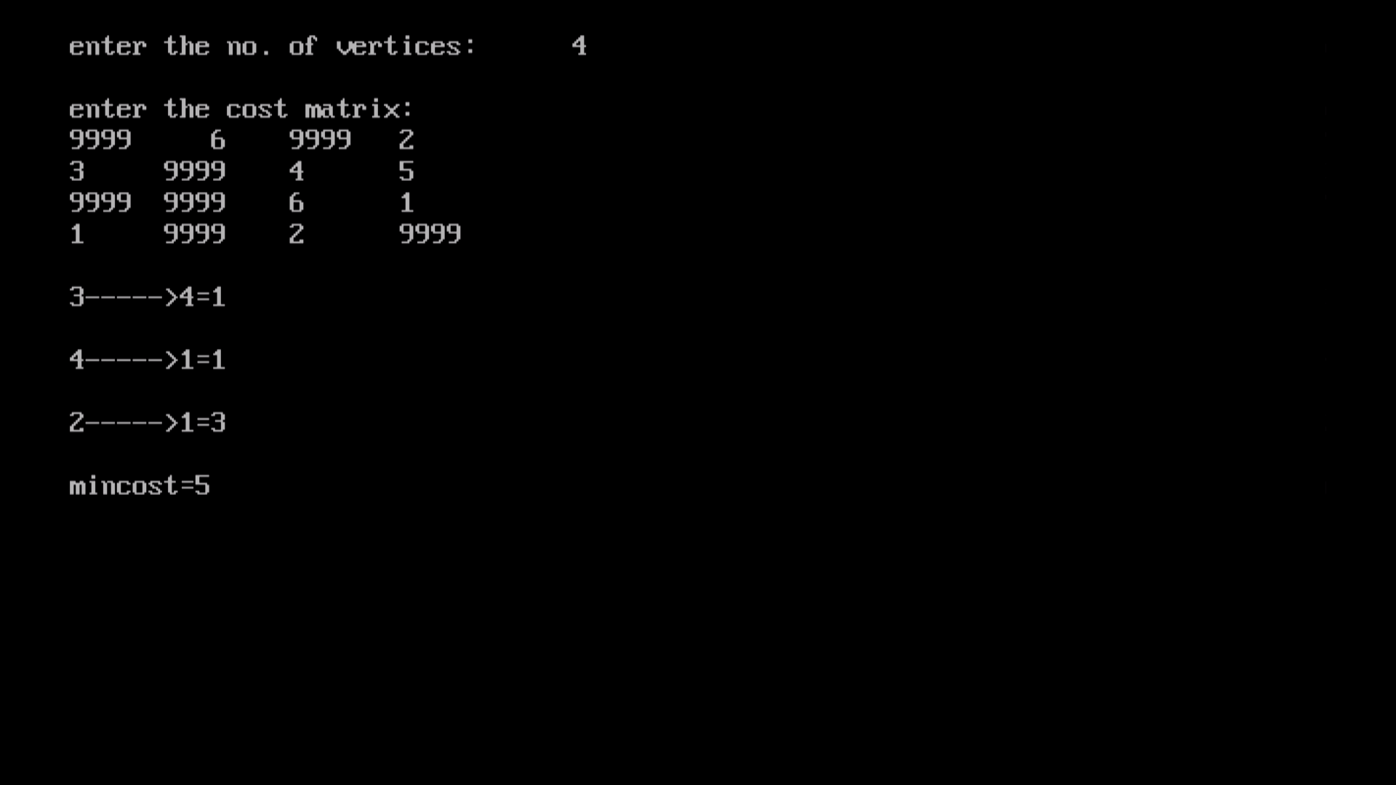

**15.Find Minimum Cost Spanning Tree of a given undirected graph using Kruskals algorithm.**

**CODE:**

#include<stdio.h>

#include<conio.h>

void kruskals();

int c[10][10],n;

void main()

{

int i,j;

clrscr();

printf("\nenter the no. of vertices:\t");

scanf("%d",&n);

printf("\nenter the cost matrix:\n");

for(i=1;i<=n;i++)

{

for(j=1;j<=n;j++)

{

scanf("%d",&c[i][j]);

}

}

kruskals();

getch();

}

void kruskals()

{

int i,j,u,v,a,b,min;

int ne=0,mincost=0;

int parent[10];

for(i=1;i<=n;i++)

{

parent[i]=0;

}

while(ne!=n-1)

{

min=9999;

for(i=1;i<=n;i++)

{

for(j=1;j<=n;j++)

{

if(c[i][j]<min)

{

min=c[i][j];

u=a=i;

v=b=j;

}

}

}

while(parent[u]!=0)

{

u=parent[u];

}

while(parent[v]!=0)

{

v=parent[v];

}

if(u!=v)

{

printf("\n%d----->%d=%d\n",a,b,min);

parent[v]=u;

ne=ne+1;

mincost=mincost+min;

}

c[a][b]=c[b][a]=9999;

}

printf("\nmincost=%d",mincost);

}

**OUTPUT:**



**16.From a given vertex in a weighted connected graph, find shortest paths to other vertices using Dijkstra’s algorithm.**

**CODE:**

#include<stdio.h>

#include<conio.h>

void dijkstras();

int c[10][10],n,src;

void main()

{

int i,j;

clrscr();

printf("\nenter the no of vertices:\t");

scanf("%d",&n);

printf("\nenter the cost matrix:\n");

for(i=1;i<=n;i++)

{

for(j=1;j<=n;j++)

{

scanf("%d",&c[i][j]);

}

}

printf("\nenter the source node:\t");

scanf("%d",&src);

dijkstras();

getch();

}

void dijkstras()

{

int vis[10],dist[10],u,j,count,min;

for(j=1;j<=n;j++)

{

dist[j]=c[src][j];

}

for(j=1;j<=n;j++)

{

vis[j]=0;

}

dist[src]=0;

vis[src]=1;

count=1;

while(count!=n)

{

min=9999;

for(j=1;j<=n;j++)

{

if(dist[j]<min&&vis[j]!=1)

{

min=dist[j];

u=j;

}

}

vis[u]=1;

count++;

for(j=1;j<=n;j++)

{

if(min+c[u][j]<dist[j]&&vis[j]!=1)

{

dist[j]=min+c[u][j];

}

}

}

printf("\nthe shortest distance is:\n");

for(j=1;j<=n;j++)

{

printf("\n%d----->%d=%d",src,j,dist[j]);

}

}

**OUTPUT:**

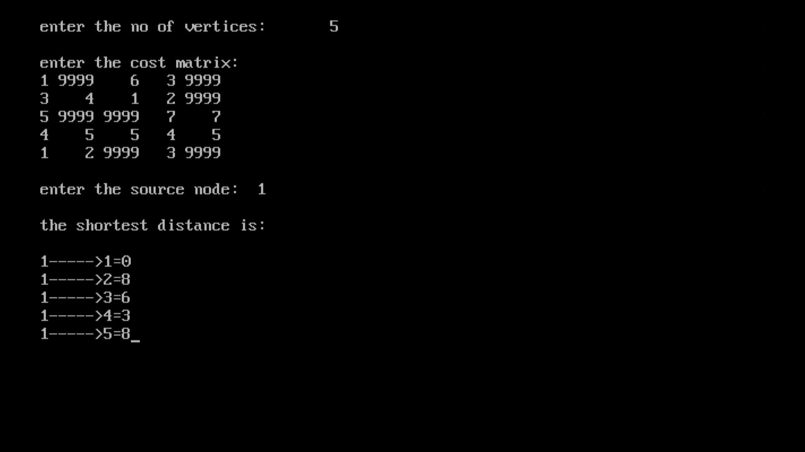

**17**.**Implement “Sum of Subsets” using Backtracking. “Sum of Subsets”problem: Find a subset of a given set S = {s1,s2,……,sn} of n positive integers whose sum is equal to a given positive integer d. For example, if S = {1,2,5,6,8} and d = 9 there are two solutions {1,2,6} and {1,8}. A suitable message is to be displayed if the given problem instance doesn’t have a solution.**

**CODE:**

#include<stdio.h>

#include<conio.h>

intcount,w[10],d,x[10];

void subset(int cs, int k, int r)

{

int i;

x[k]=1;

if(cs+w[k]==d)

{

printf("\nSubset solution = %d\n", ++count);

for(i=0;i<=k;i++)

{

if(x[i]==1)

printf("%d", w[i]);

}

}

else

if(cs+w[k]+w[k+1]<=d)

subset(cs+w[k], k+1, r-w[k]);

if((cs+r-w[k]>=d) && (cs+w[k+1])<=d)

{

x[k]=0;

subset(cs,k+1,r-w[k]);

}

}

void main()

{

int sum=0,i,n;

printf("Enter the number of elements\n");

scanf("%d", &n);

printf("Enter the elements in ascending order\n");

for(i=0;i<n;i++)

scanf("%d", &w[i]);

printf("Enter the required sum\n");

scanf("%d", &d);

for(i=0;i<n;i++)

sum+=w[i];

if(sum<d)

{

printf("No solution exists\n");

return;

}

printf("The solution is\n");

count=0;

subset(0,0,sum);

getch();

}

**OUTPUT:**

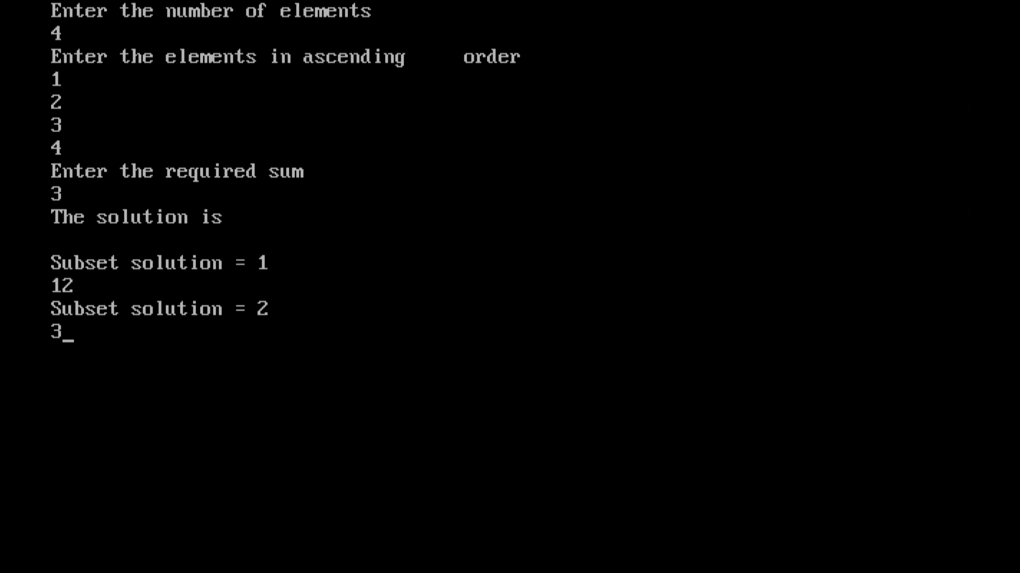

**18.Implement “N-Queens Problem” using Backtracking.**

**CODE:**

#include<stdio.h>

#include<conio.h>

void nqueens(int n)

{

Int k,x[20],count=0;

k=1;

x[k]=0;

while(k!=0)

{

x[k]++;

while(place(x,k)!=1 && x[k]<=n)

x[k]++;

if(x[k]<=n)

{

if(k==n)

{

printf("\nSolution is %d\n", ++count);

printf("Queen\t\tPosition\n");

for(k=1;k<=n;k++)

printf("%d\t\t%d\n", k,x[k]);

}

else

{

k++;

x[k]=0;

}

}

else

k--;

}

}

int place(int x[], int k)

{

int i;

for(i=1;i<=k-1;i++)

{

if(i+x[i]==k+x[k]||i-x[i]==k-x[k]||x[i]==x[k])

return 0;

}

return 1;

}

void main()

{

int n;

clrscr();

printf("Enter the number of Queens\n");

scanf("%d", &n);

nqueens(n);

getch();

}

**OUTPUT:**

